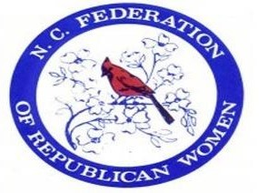

**NCFRW Regents Program**

The NCFRW Regents Program enables us to keep dues low, recruit members, fund special events, train and recruit women candidates and educate voters. Each year, our Regents will be recognized at NCFRW events, in our newsletter and on our website.

**GOLD LEVEL: $500* Year 1**: NCFRW Regent pin, NCFRW Regent bag, 1st Year Gold Gift;

**All Following Years**: Gold Gift

**SILVER LEVEL: $250* Year 1:** NCFRW Regent pin, NCFRW Regent bag, 1st Year Silver Gift; **All Following Years:** Silver Gift

**BRONZE LEVEL: $150\***  **Year 1:** NCFRW Regent pin, 1st Year Bronze Gift;

**All Following Years:** Bronze Gift

* Regent payments may be made in installments.

Thank you,

NCFRW Regents Co-Chairs,

Celeste Stanley & Debbie Dennis

To become an NCFRW Regent, please complete the following information:

Name: ___________________________________________________________

Address: _________________________________________________________

Email: ___________________________________________________________

Phone: _____________________________________________

Home Club: _________________________________________

Occupation: ______________________ Employer: _______________________

Check One: _____Gold _____Silver ______Bronze

To pay entire amount by credit card, go to the NCFRW Regents page on www.ncfrw.com.

For questions or to email this form, send to: [ncfrwregents@gmail.com](mailto:ncfrwregents@gmail.com?subject=NCFRW%20Regents%20Program)

To submit a check or to mail this form, send to:

Pam Keller 107 Country Club Road Kings Mountain, NC 28086