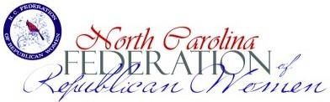

RISE AWARD

WOMEN ON THE RISE 2023
Submission Form
Club Name (In full, no initials, please)
President Email: Phone
- Recruitment- Membership
Number of reported members in final NFRW Membership report for December 2023: ______

- Involvement – Attendance of any club members at 2 out of 3 of the 2023 NCFRW Board Meetings:

Winter Board Meeting: Raleigh (Name of Attendee/s)

Spring Board Meeting: Charlotte (Name of Attendee/s) ___________________________________

Fall Board Meeting: Winston-Salem (Name of Attendee/s) ___________________

- Service – Volunteer Hours Reported, such as Caring for America, Armed Services, Literacy, etc. (Not Campaign/Political Hours)

Total Club Volunteer Hours reported for 2023:

- Education – Describe political education project(s) in 2023. Use additional page to complete question 4.

__________________________________________________________________________________________

Submit to: RISE Chair Kathy Hildreth at kathyrhildreth@gmail.com
If you have any questions, please do not hesitate to call. (828) 524-5251.
Deadline: January 5, 2024

